##### 

# Assignment Details

Assignment 4

Object Tracking Drone Application Using OpenCV, MAVSDK and PX4

Matthew Parker

Debbie Liske

[Teena Thankachan](mailto:tet275@g.harvard.edu)

Harvard University

Spring 2022

**Assignment Details** **1**

**Initial Setup** **2**

**Running the Simulation** **6**

**Install OpenCV Applications** **8**

**QUADROTOR AUTONOMOUS FLIGHT WITH PX4 AND MAVSDK** **9**

**Testing and Conclusion** **14**

**Appendix 1: Source Code** **15**

# Initial Setup

Following provided instructions to complete the initial setup:

INSTALL THE PX4 FLIGHT STACK AND JMAVSIM & GAZEBO SIMULATORS

Source ubuntu sim files:

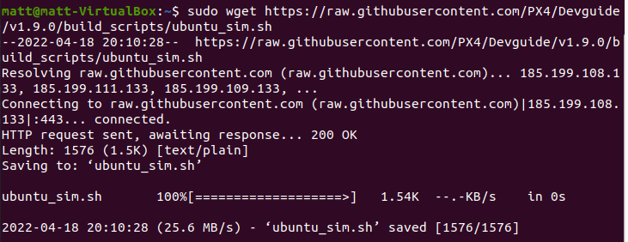

And then install:

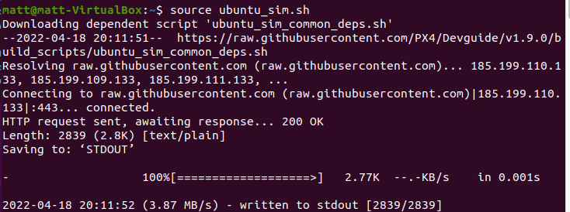

COMPILE AND RUN THE GAZEBO SIMULATOR

Install some missing packages:

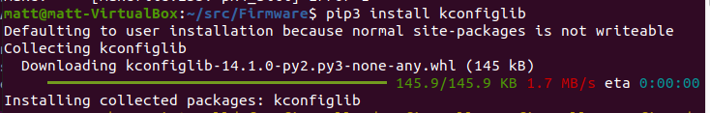

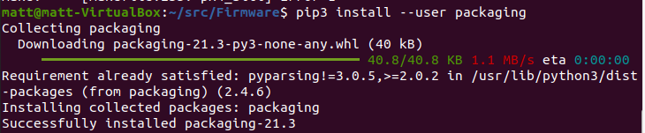

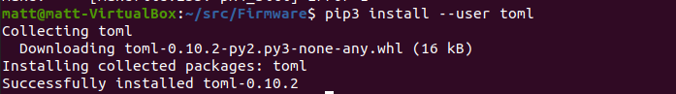

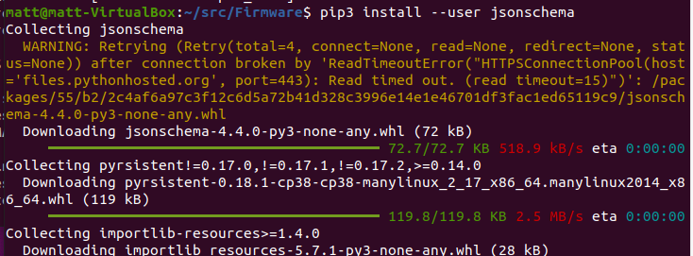

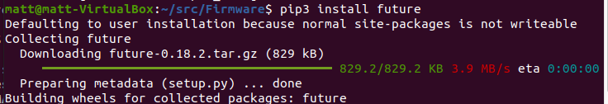

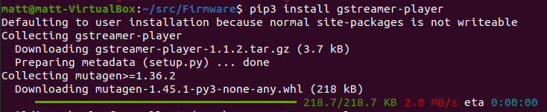

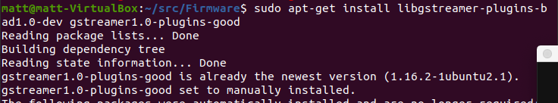

COMPILE AND RUN THE JMAVSIM SIMULATOR

Run the gazebo simulator:

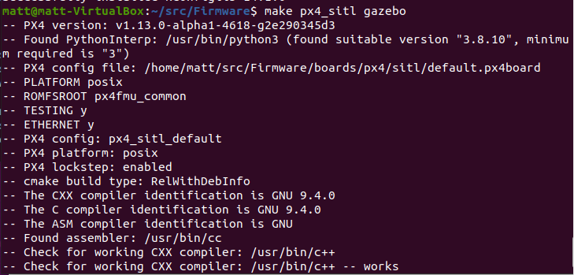

All good after going back to install some of the missing dependencies:

The drone is successfully loaded into Gazebo:

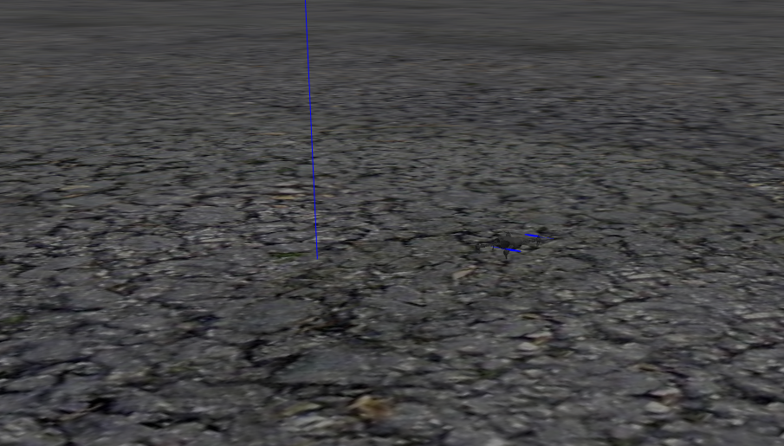

INSTALL MAVSDK-Python LIBRARY

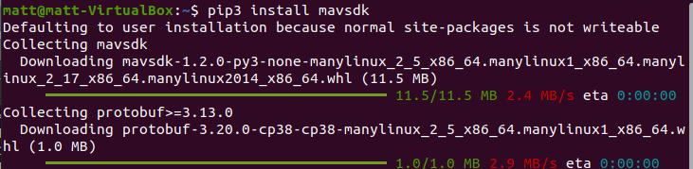

UBUNTU QGROUNDCONTROL INSTALLATION

Initial configuration:



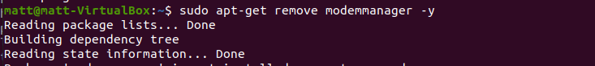

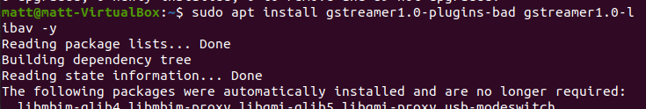

Download from the website.

<https://docs.qgroundcontrol.com/master/en/getting_started/download_and_install.html>

Go to downloads and make file executable:



And run:

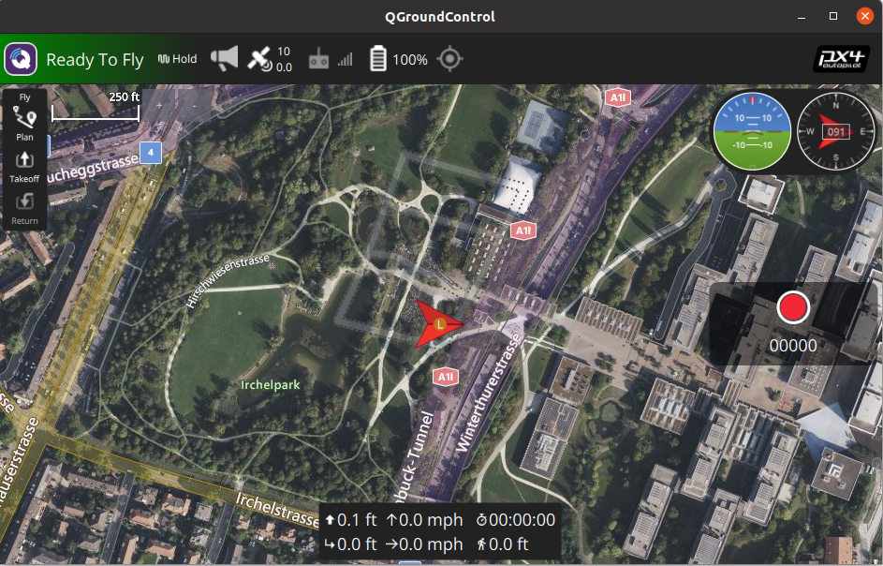

# Running the Simulation

Verify some examples:

* Takeoff and Land:
  + 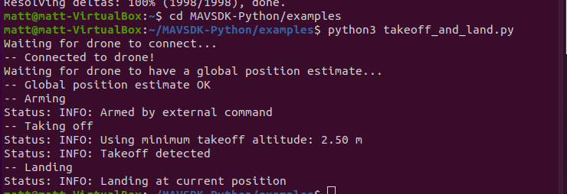
* Running the mission.py example:
  + 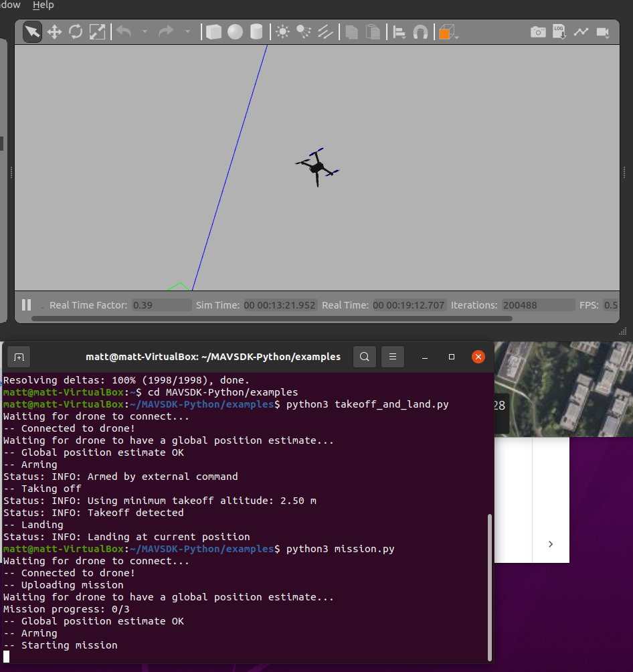
  + 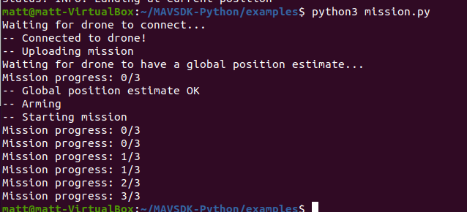

Attempting a basic trajectory from QGroundControl to ensure the drone is moving (Success!)

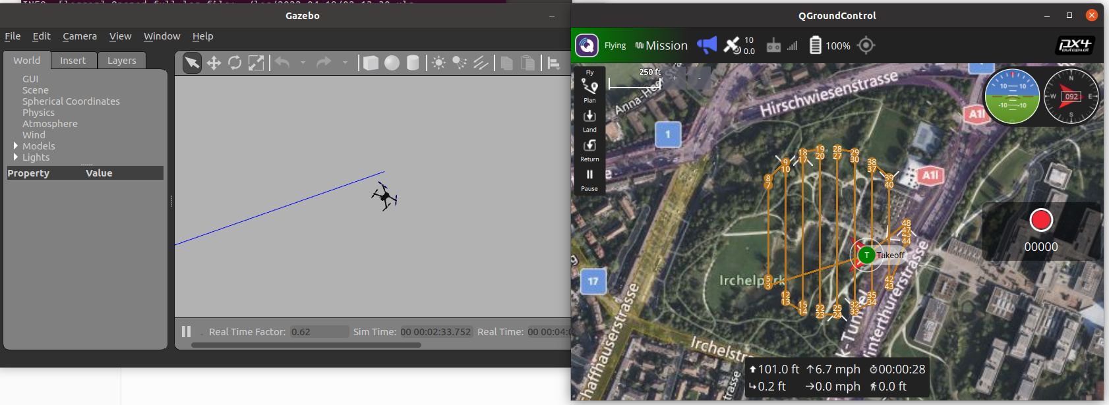

# Install OpenCV Applications

## INSTALL OPENCV

Update packages:

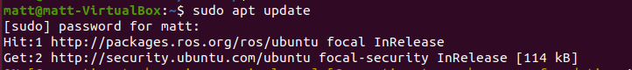

Install OpenCV app

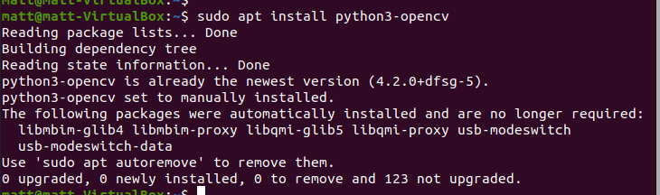

## TEST YOUR OPENCV INSTALLATION

Run the 'detect_test' setup first to confirm the camera and object tracking is working correctly.

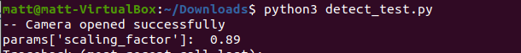

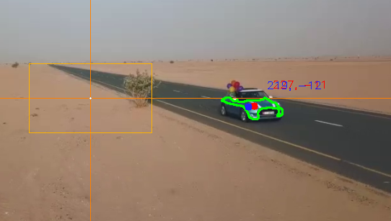

# QUADROTOR AUTONOMOUS FLIGHT WITH PX4 AND MAVSDK

Run the following commands:

* cd ~/ # To change directory to your home directory
* Wget https://raw.githubusercontent.com/PX4/Devguide/v1.9.0/build_scripts/ubuntu_sim.sh
* source ubuntu_sim.sh

After the installation finishes, the directory will be automatically changed to: ~/src/Firmware

To compile the Gazebo simulator, run:

make px4_sitl gazebo

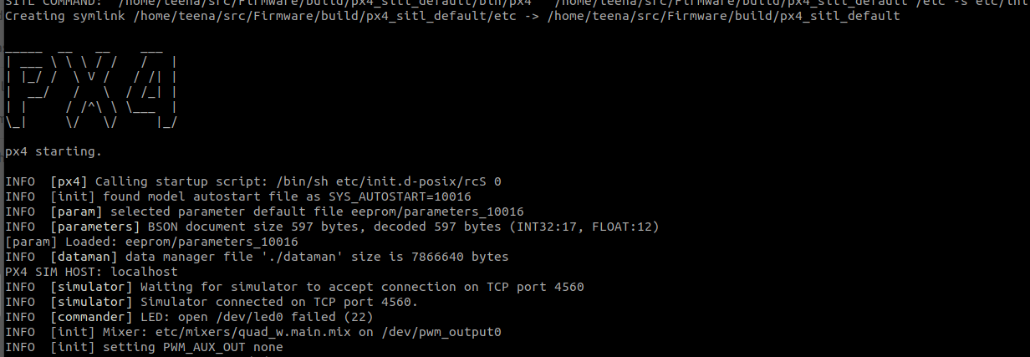

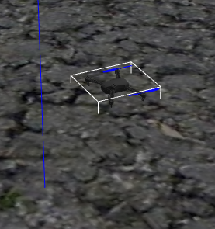

## 7. INSTALL MAVSDK-Python LIBRARY

Check the official installation guide at: https://github.com/mavlink/MAVSDK-Python

To install MAVSDK-Python, simply run:

pip3 install mavsdk

To clone the MAVSDK-Python repository with the basic examples, simply run:

cd ~/ # To download the repository in your home directory

git clone https://github.com/mavlink/MAVSDK-Python.git

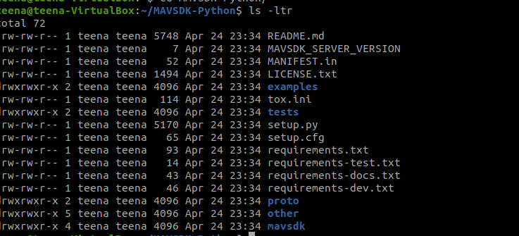

## 8. UBUNTU QGROUNDCONTROL INSTALLATION

Check the official installation guide at: https://docs.qgroundcontrol.com/en/getting_started/download_and_install.html

Before installing QGroundControl for the first time:

1. On the command prompt enter:

sudo usermod -a -G dialout $USER

sudo apt-get remove modemmanager -y

sudo apt install gstreamer1.0-plugins-bad gstreamer1.0-libav -y

Logout and login again to enable the change to user permissions.

2. To install QGroundControl for Ubuntu Linux 16.04 LTS or later:

- Download QGroundControl.AppImage.

- Install (and run) using the terminal commands:

chmod +x ./QGroundControl.AppImage

./QGroundControl.AppImage (or double click)

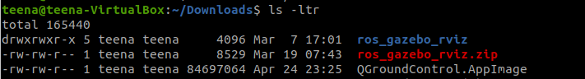

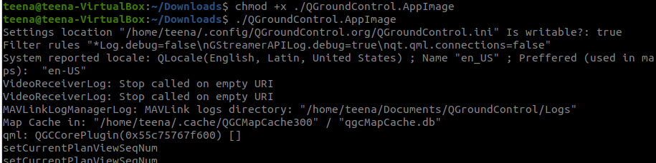

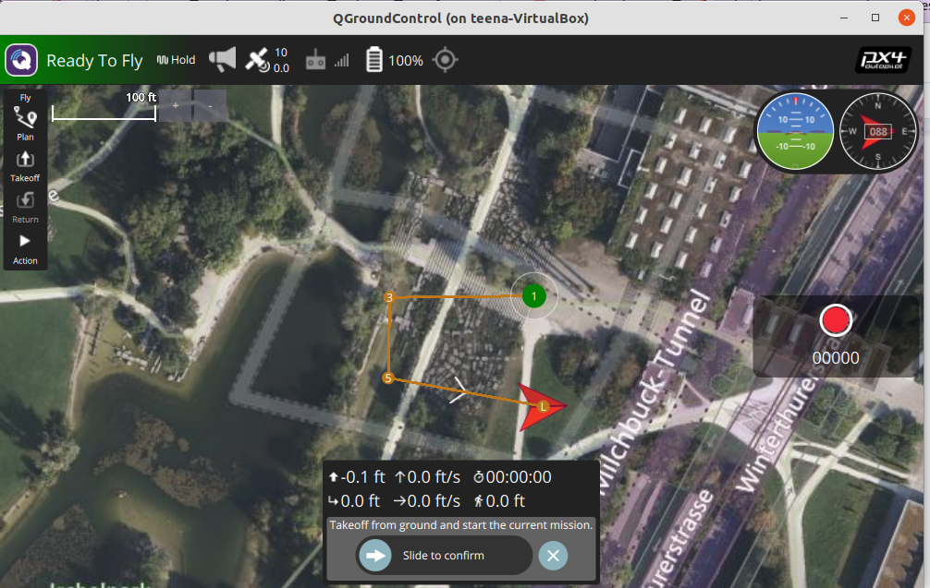

## 11. RUN IN SIMULATION THE EXAMPLE PRESENTED IN THE ARTICLE

* On command terminal window 1 run:

cd ~/src/Firmware

make px4_sitl gazebo

Open QGroundControl software.

Path Planning :

Uploaded a basic survey plan on the drone:

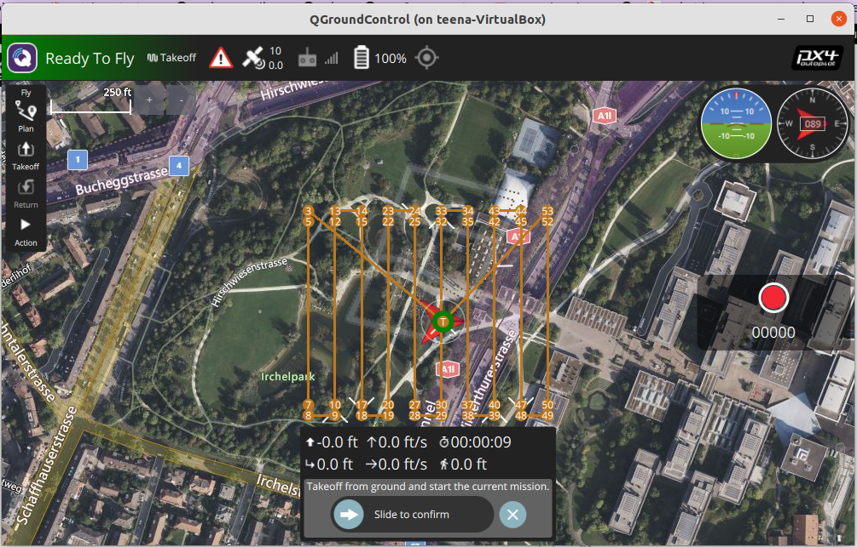

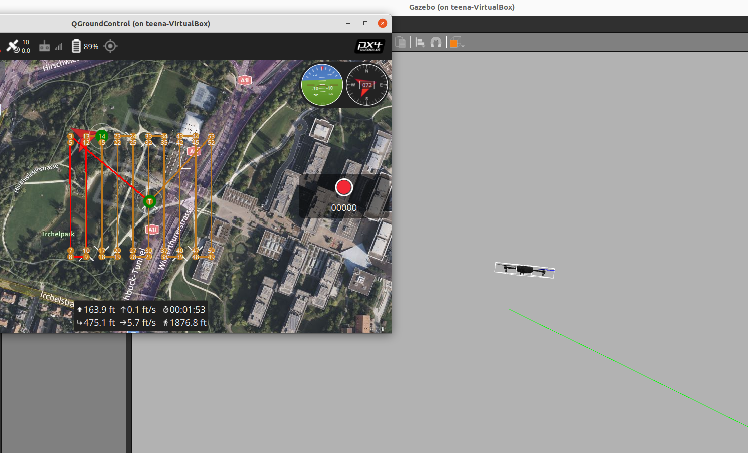

Running drone from python commands :

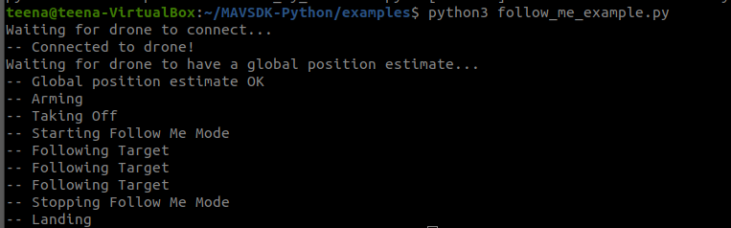

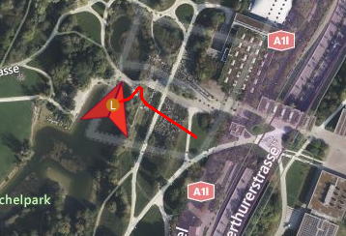

# Testing Autonomous Control

To test the code example in simulation, take the following steps:

1. First, run the PX4 & Gazebo, or PX4 & JMAVSim simulator.
2. Second, open QGroundControl.
3. Third, run the *track_and_follow.py* script.

If the camera detects a blue object within the HSV color range defined in the code, you will see the drone moving over QGroundControl’s map in the direction of the detected target. Furthermore, if you move the blue target in front of the camera, the drone will move in the same direction, tracking the target only when it is outside the center rectangle. The *run_track_and_follow.md* text file summarizes all detailed steps to run the code in simulation. The figure below shows a screen capture of the *track_and_follow.py* script running.

Commands used to run

* make px4_sitl gazebo
* ./QGroundControl.AppImage
* python3 *track_and_follow.py*

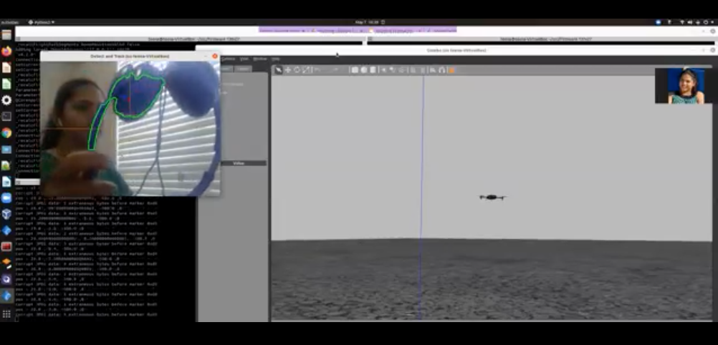

# Appendix 1: Source Code

Git Link:

<https://github.com/debbieliske/DGMD_Robotics.git>

A description of each file is provided below, with the full source code copied to the appendix:

1. Detect and Test
   1. detect_test.py file
   2. This code uses a previously recorded video in lieu of the camera input to verify the object detection and positioning software is functioning. The video is a blue car driving down the road, and the code will detect and follow the car as it moves through the frame.
2. Track and Follow
   1. track_and_follow_edit.py file
   2. This is the main function for the autonomous drone operations. Once the drone is flying and is put into autonomous mode, the program will import images from the camera, detect objects, and send drone steering commands to follow the position of the object.

1. **Track and Follow Python Code**

#!/usr/bin/env python3

'''

'track_and_follow.py'

The drone follows an object detected by using color range segmentation with OpenCV.

Author: Raul Alvarez-Torrico (raul@tecbolivia.com)

This code example is based in part on the 'offboard_position_ned.py' and the 'telemetry_takeoff_and_land.py'

examples included in the MAVSDK-Python repository (see the 'examples' folder).

For an introduction to MAVSDK development with SITL simulation and all things related to MAVSDK,

PX4 SITL simulation and Python asynchronous programming with the ‘asyncio’ library, please refer

to my previous "Circuit Cellar" article "Quadrotor Autonomous Flight with PX4 and MAVSDK"

(Circuit Cellar [number], [month] 2019)

'''

import asyncio

import cv2

from mavsdk import System

#from mavsdk import (OffboardError, PositionNedYaw)

from mavsdk.offboard import PositionNedYaw as PositionNedYaw

from mavsdk.offboard import OffboardError as OffboardError

# Constants

PERCENT_CENTER_RECT = 0.20 # For calculating the center rectangle's size

PERCENT_TARGET_RADIUS = 0.25 * PERCENT_CENTER_RECT # Minimum target radius to follow

HOVERING_ALTITUDE = 500.0 # Altitude in meters to which the drone will perform its tasks

NUM_FILT_POINTS = 20 # Number of filtering points for the Moving Average Filter

DESIRED_IMAGE_HEIGHT = 480 # A smaller image makes the detection less CPU intensive

# A dictionary of two empty buffers (arrays) for the Moving Average Filter

filt_buffer = {'width':[], 'height':[]}

# A dictionary of general parameters derived from the camera image size,

# which will be populated later with the 'get_image_params' function

params = {'image_height':None, 'image_width': None,'resized_height':None,'resized_width': None,

'x_ax_pos':None, 'y_ax_pos':None, 'cent_rect_half_width':None, 'cent_rect_half_height': None,

'cent_rect_p1': None, 'cent_rect_p2': None, 'scaling_factor':None, 'min_tgt_radius':None}

### ---------- This is the application's 'main' asynchronous function ----------

async def run():

""" Detects a target by using color range segmentation and follows it

by using Offboard control and position NED coordinates. """

# Open the video camera

vid_cam = cv2.VideoCapture(0)

# Let the camera warm up

# await asyncio.sleep(2)

# Check if the camera opened correctly

if vid_cam.isOpened() is False:

print('[ERROR] Couldnt open the camera.')

return

print('-- Camera opened successfully')

# Compute general parameters

await get_image_params(vid_cam)

print(f"-- Original image width, height: {params['image_width']}, {params['image_height']}")

# Get a reference to a 'System' object, which represents the drone,

# and open a connection to it. The system address used here is the default

# address for a simulated drone running in the same machine machine where

# this code will run (localhost)

drone = System()

await drone.connect(system_address="udp://:14540") # To run with SITL simulation

# ------ To run the code with a real drone connected to the PC via telemetry modules ------ #

# await drone.connect(system_address="serial:///dev/ttyUSB0:57600")

# CAUTION: Color range segmentation is not the best approach to detect and track objects

# This example is just a didactic proof of concept. Don't run it with a real drone

# unless you have good experience flying real drones and know what you are doing.

# ----------------------------------------------------------------------------------------- #

# Asynchronously poll the connection state until receiving an 'is_connected' confirmation

print("Waiting for drone to connect...")

async for state in drone.core.connection_state():

print(f"Drone discovered with is_connected: {state.is_connected}")

if state.is_connected:

#print(f"Drone discovered with UUID: {state.uuid}")

break

# Activate the drone motors

print("-- Arming")

await drone.action.arm()

# Send an initial position to the drone before changing to "offboard" flight mode

print("-- Setting initial setpoint")

await drone.offboard.set_position_ned(PositionNedYaw(0.0, 0.0, 0.0, 0.0))

# Change flight mode to "offboard", if it fails, disarm the motors and abort the script

print("-- Starting offboard")

try:

await drone.offboard.start()

except OffboardError as error:

print(f"Starting offboard mode failed with error code: {error._result.result}")

print("-- Disarming")

await drone.action.disarm()

return

# Variables to store the NED coordinates, plus Yaw angle. Default pose:

N_coord = 0

E_coord = 0

D_coord = -HOVERING_ALTITUDE # The drone will always detect and track at HOVERING_ALTITUDE

yaw_angle = 0 # Drone always points to North

print("-- Taking off")

await drone.action.takeoff()

print("-- Go 0m North, 0m East, -5m Down within local coordinate system")

await drone.offboard.set_position_ned(PositionNedYaw(0.0, 0.0, -5.0, 0.0))

await asyncio.sleep(10)

# Make the drone go (take off) to the default pose

print("-- Drone set pos")

await drone.offboard.set_position_ned(

PositionNedYaw(N_coord, E_coord, D_coord, yaw_angle))

await asyncio.sleep(4) # Give the drone time to gain altitude

# Infinite detect-follow loop

while True:

# Get the target coordinates (if any target was detected)

tgt_cam_coord, frame, contour = await get_target_coordinates(vid_cam)

# If a target was found, filter their coordinates

if tgt_cam_coord['width'] is not None and tgt_cam_coord['height'] is not None:

# Apply Moving Average filter to target camera coordinates

tgt_filt_cam_coord = await moving_average_filter(tgt_cam_coord)

# No target was found, set target camera coordinates to the Cartesian origin,

# so the drone doesn't move

else:

# The Cartesian origin is where the x and y Cartesian axes are located

# in the image, in pixel units

tgt_cam_coord = {'width':params['y_ax_pos'], 'height':params['x_ax_pos']} # Needed just for drawing objects

tgt_filt_cam_coord = {'width':params['y_ax_pos'], 'height':params['x_ax_pos']}

# Convert from camera coordinates to Cartesian coordinates (in pixel units)

tgt_cart_coord = {'x':(tgt_filt_cam_coord['width'] - params['y_ax_pos']),

'y':(params['x_ax_pos'] - tgt_filt_cam_coord['height'])}

# Compute scaling conversion factor from camera coordinates in pixel units

# to Cartesian coordinates in meters

COORD_SYS_CONV_FACTOR = 0.1

# If the target is outside the center rectangle, compute North and East coordinates

if abs(tgt_cart_coord['x']) > params['cent_rect_half_width'] or \

abs(tgt_cart_coord['y']) > params['cent_rect_half_height']:

# Compute North, East coordinates applying "camera pixel" to Cartesian conversion factor

E_coord = tgt_cart_coord['x'] * COORD_SYS_CONV_FACTOR

N_coord = tgt_cart_coord['y'] * COORD_SYS_CONV_FACTOR

# D_coord, yaw_angle don't change

# Command the drone to the current NED + Yaw pose

await drone.offboard.set_position_ned(

PositionNedYaw(N_coord, E_coord, D_coord, yaw_angle))

print(f"pos : {N_coord} ,{E_coord}, {D_coord} ,{yaw_angle}")

# Draw objects over the detection image frame just for visualization

frame = await draw_objects(tgt_cam_coord, tgt_filt_cam_coord, frame, contour)

# Show the detection image frame on screen

cv2.imshow("Detect and Track", frame)

# Catch aborting key from computer keyboard

key = cv2.waitKey(1) & 0xFF

# If the 'q' key is pressed, break the 'while' infinite loop

if key == ord("q"):

break

# After leaving the infinite loop, return the drone to home before ending the script

print("-- Return to launch...")

# await drone.action.return_to_launch()

await drone.action.land()

print("NOTE: check the drone has landed already before running again this script.")

await asyncio.sleep(5) # Wait some time while the drone executes last command

async def get_image_params(vid_cam):

""" Computes useful general parameters derived from the camera image size."""

# Grab a frame and get its size

is_grabbed, frame = vid_cam.read()

params['image_height'], params['image_width'], _ = frame.shape

# Compute the scaling factor to scale the image to a desired size

if params['image_height'] != DESIRED_IMAGE_HEIGHT:

params['scaling_factor'] = round((DESIRED_IMAGE_HEIGHT / params['image_height']), 2) # Rounded scaling factor

else:

params['scaling_factor'] = 1

print("params['scaling_factor']: ", params['scaling_factor'])

# Compute resized width and height and resize the image

params['resized_width'] = int(params['image_width'] * params['scaling_factor'])

params['resized_height'] = int(params['image_height'] * params['scaling_factor'])

dimension = (params['resized_width'], params['resized_height'])

frame = cv2.resize(frame, dimension, interpolation = cv2.INTER_AREA)

# Compute the center rectangle's half width and half height

params['cent_rect_half_width'] = round(params['resized_width'] * (0.5 * PERCENT_CENTER_RECT)) # Use half percent (0.5)

params['cent_rect_half_height'] = round(params['resized_height'] * (0.5 * PERCENT_CENTER_RECT)) # Use half percent (0.5)

# Compute the minimum target radius to follow. Smaller detected targets will be ignored

params['min_tgt_radius'] = round(params['resized_width'] * PERCENT_TARGET_RADIUS)

# Compute the position for the X and Y Cartesian coordinates in camera pixel units

params['x_ax_pos'] = int(params['resized_height']/2 - 1)

params['y_ax_pos'] = int(params['resized_width']/2 - 1)

# Compute two points: p1 in the upper left and p2 in the lower right that will be used to

# draw the center rectangle iin the image frame

params['cent_rect_p1'] = (params['y_ax_pos'] - params['cent_rect_half_width'],

params['x_ax_pos'] - params['cent_rect_half_height'])

params['cent_rect_p2'] = (params['y_ax_pos'] + params['cent_rect_half_width'],

params['x_ax_pos'] + params['cent_rect_half_height'])

return

async def get_target_coordinates(vid_cam):

""" Detects a target by using color range segmentation and returns its 'camera pixel' coordinates."""

# Use the 'threshold_inRange.py' script included with the code to get

# your own bounds with any color

# To detect a blue target:

HSV_LOWER_BOUND = (107, 119, 41)

HSV_UPPER_BOUND = (124, 255, 255)

# Grab a frame in BGR (Blue, Green, Red) space color

is_grabbed, frame = vid_cam.read()

# Resize the image frame for the detection process, if needed

if params['scaling_factor'] != 1:

dimension = (params['resized_width'], params['resized_height'])

frame = cv2.resize(frame, dimension, interpolation = cv2.INTER_AREA)

# Blur the image to remove high frequency content

blurred = cv2.GaussianBlur(frame, (11, 11), 0)

# Change color space from BGR to HSV

hsv = cv2.cvtColor(blurred, cv2.COLOR_BGR2HSV)

# Histogram equalisation to minimize the effect of variable lighting

# hsv[:, :, 0] = cv2.equalizeHist(hsv[:, :, 0]) # on the H-channel

# hsv[:, :, 1] = cv2.equalizeHist(hsv[:, :, 1]) # on the S-channel

# hsv[:, :, 2] = cv2.equalizeHist(hsv[:, :, 2]) # on the V-channel

# Get a mask with all the pixels inside our defined color boundaries

mask = cv2.inRange(hsv, HSV_LOWER_BOUND, HSV_UPPER_BOUND)

# Erode and dilate to remove small blobs

mask = cv2.erode(mask, None, iterations=3)

mask = cv2.dilate(mask, None, iterations=3)

# Find all contours in the masked image

#tt_, contours, _ = cv2.findContours(mask, cv2.RETR_EXTERNAL, cv2.CHAIN_APPROX_SIMPLE)

#ttcontours, hierarchy= cv2.findContours(mask, cv2.RETR_EXTERNAL, cv2.CHAIN_APPROX_SIMPLE)

contours , _ = cv2.findContours(mask, cv2.RETR_EXTERNAL, cv2.CHAIN_APPROX_SIMPLE)

# Centroid coordinates to be returned:

cX = None

cY = None

# To save the larges contour, presumably the detected object

largest_contour = None

# Check if at least one contour was found

if len(contours) > 0:

# Get the largest contour of all posibly detected

largest_contour = max(contours, key=cv2.contourArea)

# Compute the radius of an enclosing circle aorund the largest contour

((x, y), radius) = cv2.minEnclosingCircle(largest_contour)

# Compute centroid only if contour radius is larger than 0.5 half the center rectangle

if radius > params['min_tgt_radius']:

# Compute contour raw moments

M = cv2.moments(largest_contour)

# Get the contour's centroid

cX = int(M["m10"] / M["m00"])

cY = int(M["m01"] / M["m00"])

# Return centroid coordinates (camera pixel units), the analized frame and the largest contour

return {'width':cX, 'height':cY}, frame, largest_contour

async def moving_average_filter(coord):

""" Applies Low-Pass Moving Average Filter to a pair of (x, y) coordinates."""

# Append new coordinates to filter buffers

filt_buffer['width'].append(coord['width'])

filt_buffer['height'].append(coord['height'])

# If the filters were full already with a number of NUM_FILT_POINTS values,

# discard the oldest value (FIFO buffer)

if len(filt_buffer['width']) > NUM_FILT_POINTS:

filt_buffer['width'] = filt_buffer['width'][1:]

filt_buffer['height'] = filt_buffer['height'][1:]

# Compute filtered camera coordinates

N = len(filt_buffer['width']) # Get the number of values in buffers (will be < NUM_FILT_POINTS at the start)

# Sum all values for each coordinate

w_sum = sum( filt_buffer['width'] )

h_sum = sum( filt_buffer['height'] )

# Compute the average

w_filt = int(round(w_sum / N))

h_filt = int(round(h_sum / N))

# Return filtered coordinates as a dictionary

return {'width':w_filt, 'height':h_filt}

async def draw_objects(cam_coord, filt_cam_coord, frame, contour):

""" Draws visualization objects from the detection process.

Position coordinates of every object are always in 'camera pixel' units"""

# Draw the Cartesian axes

cv2.line(frame, (0, params['x_ax_pos']), (params['resized_width'], params['x_ax_pos']), (0, 128, 255), 1)

cv2.line(frame, (params['y_ax_pos'], 0), (params['y_ax_pos'], params['resized_height']), (0, 128, 255), 1)

cv2.circle(frame, (params['y_ax_pos'], params['x_ax_pos']), 1, (255, 255, 255), -1)

# Draw the center (tolerance) rectangle

cv2.rectangle(frame, params['cent_rect_p1'], params['cent_rect_p2'], (0, 178, 255), 1)

# Draw the detected object's contour, if any

cv2.drawContours(frame, [contour], -1, (0, 255, 0), 2)

# Compute Cartesian coordinates of unfiltered detected object's centroid

x_cart_coord = cam_coord['width'] - params['y_ax_pos']

y_cart_coord = params['x_ax_pos'] - cam_coord['height']

# Compute Cartesian coordinates of filtered detected object's centroid

x_filt_cart_coord = filt_cam_coord['width'] - params['y_ax_pos']

y_filt_cart_coord = params['x_ax_pos'] - filt_cam_coord['height']

# Draw unfiltered centroid as a red dot, including coordinate values

cv2.circle(frame, (cam_coord['width'], cam_coord['height']), 5, (0, 0, 255), -1)

cv2.putText(frame, str(x_cart_coord) + ", " + str(y_cart_coord),

(cam_coord['width'] + 25, cam_coord['height'] - 25), cv2.FONT_HERSHEY_SIMPLEX, 0.5, (0, 0, 255), 1)

# Draw filtered centroid as a blue dot, including coordinate values

cv2.circle(frame, (filt_cam_coord['width'], filt_cam_coord['height']), 5, (255, 30, 30), -1)

cv2.putText(frame, str(x_filt_cart_coord) + ", " + str(y_filt_cart_coord),

(filt_cam_coord['width'] + 25, filt_cam_coord['height'] - 25), cv2.FONT_HERSHEY_SIMPLEX, 0.5, (255, 30, 30), 1)

return frame # Return the image frame with all drawn objects

if __name__ == "__main__":

loop = asyncio.get_event_loop()

loop.run_until_complete(run())

1. **OpenCV Python Code**

### ---------- This is the application's 'main' asynchronous function ----------

async def run():

""" Detects a target by using color range segmentation and follows it

by using Offboard control and position NED coordinates. """

vid_cam = cv2.VideoCapture(0)

if vid_cam.isOpened() is False:

print('[ERROR] Couldnt open the camera.')

return

print('-- Camera opened successfully')

await get_image_params(vid_cam)

print(f"-- Original image width, height: {params['image_width']}, {params['image_height']}")

drone = System()

await drone.connect(system_address="udp://:14540")

# ... Additional drone initialization code lines go here...

N_coord = 0

E_coord = 0

D_coord = -HOVERING_ALTITUDE

yaw_angle = 0

await drone.offboard.set_position_ned(PositionNedYaw(N_coord, E_coord, D_coord, yaw_angle))

await asyncio.sleep(4)

while True:

tgt_cam_coord, frame, contour = await get_target_coordinates(vid_cam)

if tgt_cam_coord['width'] is not None and tgt_cam_coord['height'] is not None:

tgt_filt_cam_coord = await moving_average_filter(tgt_cam_coord)

else:

tgt_cam_coord = {'width':params['y_ax_pos'], 'height':params['x_ax_pos']}

tgt_filt_cam_coord = {'width':params['y_ax_pos'], 'height':params['x_ax_pos']}

tgt_cart_coord = {'x':(tgt_filt_cam_coord['width'] - params['y_ax_pos']),

'y':(params['x_ax_pos'] - tgt_filt_cam_coord['height'])}

COORD_SYS_CONV_FACTOR = 0.1

if abs(tgt_cart_coord['x']) > params['cent_rect_half_width'] or \

abs(tgt_cart_coord['y']) > params['cent_rect_half_height']:

E_coord = tgt_cart_coord['x'] * COORD_SYS_CONV_FACTOR

N_coord = tgt_cart_coord['y'] * COORD_SYS_CONV_FACTOR

# D_coord, yaw_angle don't change

await drone.offboard.set_position_ned(PositionNedYaw(N_coord, E_coord, D_coord, yaw_angle))

frame = await draw_objects(tgt_cam_coord, tgt_filt_cam_coord, frame, contour)

cv2.imshow("Detect and Track", frame)

key = cv2.waitKey(1) & 0xFF

if key == ord("q"):

break

print("-- Return to launch...")

await drone.action.return_to_launch()

print("NOTE: check the drone has landed already before running again this script.")

await asyncio.sleep(5)

async def get_image_params(vid_cam):

""" Computes useful general parameters derived from the camera image size."""

_, frame = vid_cam.read()

params['image_height'], params['image_width'], _ = frame.shape

if params['image_height'] != DESIRED_IMAGE_HEIGHT:

params['scaling_factor'] = round((DESIRED_IMAGE_HEIGHT / params['image_height']), 2)

else:

params['scaling_factor'] = 1

params['resized_width'] = int(params['image_width'] * params['scaling_factor'])

params['resized_height'] = int(params['image_height'] * params['scaling_factor'])

dimension = (params['resized_width'], params['resized_height'])

frame = cv2.resize(frame, dimension, interpolation = cv2.INTER_AREA)

params['cent_rect_half_width'] = round(params['resized_width'] * (0.5 * PERCENT_CENTER_RECT))

params['cent_rect_half_height'] = round(params['resized_height'] * (0.5 * PERCENT_CENTER_RECT))

params['min_tgt_radius'] = round(params['resized_width'] * PERCENT_TARGET_RADIUS)

params['x_ax_pos'] = int(params['resized_height']/2 - 1)

params['y_ax_pos'] = int(params['resized_width']/2 - 1)

params['cent_rect_p1'] = (params['y_ax_pos']-params['cent_rect_half_width'],

params['x_ax_pos']-params['cent_rect_half_height'])

params['cent_rect_p2'] = (params['y_ax_pos']+params['cent_rect_half_width'],

params['x_ax_pos']+params['cent_rect_half_height'])

return

async def get_target_coordinates(vid_cam):

""" Detects a target by using color range segmentation and returns its

'camera pixel' coordinates."""

HSV_LOWER_BOUND = (107, 119, 41)

HSV_UPPER_BOUND = (124, 255, 255)

_, frame = vid_cam.read()

if params['scaling_factor'] != 1:

dimension = (params['resized_width'], params['resized_height'])

frame = cv2.resize(frame, dimension, interpolation = cv2.INTER_AREA)

blurred = cv2.GaussianBlur(frame, (11, 11), 0)

hsv = cv2.cvtColor(blurred, cv2.COLOR_BGR2HSV)

mask = cv2.inRange(hsv, HSV_LOWER_BOUND, HSV_UPPER_BOUND)

mask = cv2.erode(mask, None, iterations=3)

mask = cv2.dilate(mask, None, iterations=3)

_, contours, _ = cv2.findContours(mask, cv2.RETR_EXTERNAL, cv2.CHAIN_APPROX_SIMPLE)

cX = None

cY = None

largest_contour = None

if len(contours) > 0:

largest_contour = max(contours, key=cv2.contourArea)

((x, y), radius) = cv2.minEnclosingCircle(largest_contour)

if radius > params['min_tgt_radius']:

M = cv2.moments(largest_contour)

cX = int(M["m10"] / M["m00"])

cY = int(M["m01"] / M["m00"])

return {'width':cX, 'height':cY}, frame, largest_contour

async def moving_average_filter(coord):

""" Applies Low-Pass Moving Average Filter to a pair of (x, y) coordinates."""

filt_buffer['width'].append(coord['width'])

filt_buffer['height'].append(coord['height'])

if len(filt_buffer['width']) > NUM_FILT_POINTS:

filt_buffer['width'] = filt_buffer['width'][1:]

filt_buffer['height'] = filt_buffer['height'][1:]

N = len(filt_buffer['width'])

w_sum = sum( filt_buffer['width'] )

h_sum = sum( filt_buffer['height'] )

w_filt = int(round(w_sum / N))

h_filt = int(round(h_sum / N))

return {'width':w_filt, 'height':h_filt}

async def draw_objects(cam_coord, filt_cam_coord, frame, contour):

""" Draws visualization objects from the detection process.

Position coordinates of every object are always in 'camera pixel' units"""

cv2.line(frame, (0, params['x_ax_pos']), (params['resized_width'], params['x_ax_pos']), (0, 128, 255), 1)

cv2.line(frame, (params['y_ax_pos'], 0), (params['y_ax_pos'], params['resized_height']), (0, 128, 255), 1)

cv2.circle(frame, (params['y_ax_pos'], params['x_ax_pos']), 1, (255, 255, 255), -1)

cv2.rectangle(frame, params['cent_rect_p1'], params['cent_rect_p2'], (0, 178, 255), 1)

cv2.drawContours(frame, [contour], -1, (0, 255, 0), 2)

x_cart_coord = cam_coord['width'] - params['y_ax_pos']

y_cart_coord = params['x_ax_pos'] - cam_coord['height']

x_filt_cart_coord = filt_cam_coord['width'] - params['y_ax_pos']

y_filt_cart_coord = params['x_ax_pos'] - filt_cam_coord['height']

cv2.circle(frame, (cam_coord['width'], cam_coord['height']), 5, (0, 0, 255), -1)

cv2.putText(frame, str(x_cart_coord) + ", " + str(y_cart_coord),

(cam_coord['width'] + 25, cam_coord['height'] - 25), cv2.FONT_HERSHEY_SIMPLEX, 0.5, (0, 0, 255), 1)

cv2.circle(frame, (filt_cam_coord['width'], filt_cam_coord['height']), 5, (255, 30, 30), -1)

cv2.putText(frame, str(x_filt_cart_coord) + ", " + str(y_filt_cart_coord),

(filt_cam_coord['width'] + 25, filt_cam_coord['height'] - 25), cv2.FONT_HERSHEY_SIMPLEX, 0.5, (255, 30, 30), 1)

return frame

**####################################Teena###############################**